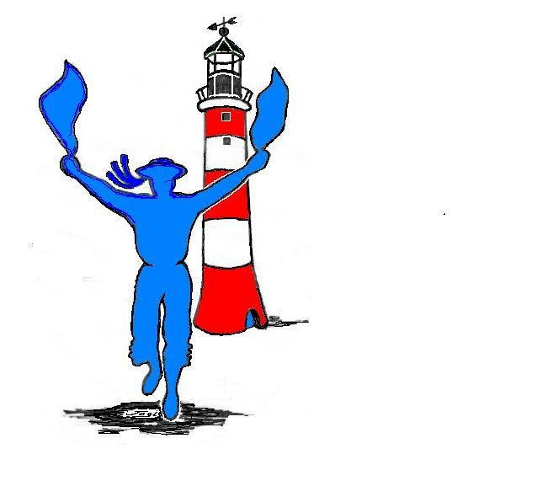

Plymouth Morris Men

THIS PROGRAMME IS PROVISIONAL
Whilst every effort will be made to appear at the declared times, it may be necessary to cancel or
re-arrange dance spots as the season progresses due to the weather, availability of dancers and musicians, or any other unforeseen circumstances.
E&OE.

PMM donations to charities
£7000 since year 2001 include:
£1458 to cancer charities, £1117 to Meningitis Trust,
£500 (+ £500 from Wessex Trains) to St Luke's Hospice,
£300 for Care and Repair (Plymouth), £95 for Tsunami Appeal,
2008-09 £263 to Macmillan Nurses at Derriford Hospital
2009: £300 to St Austell Brewery Charitable Trust
2010 £939 to Sport Relief (for the sponsored mile)
2009-11 £1200 to The Chestnut Appeal
2012 £700 to St Luke’s Hospice
2012-13 £240 to St. Luke's Hospice and the RNLI via Dolphin
2014 £408 to Plymouth Heartbeat

Our nominated charity for 2013/14
is Devon Freewheelers

To book us for your function,
please contact Joe  07831 442603

January 2014
Wed 01 12:00 Dolphin Inn, Plymouth Barbican
Sat 25 19:00 Woolwell Centre PL6 7TR
44th Annual Ceilidh with Fox Amongst The Chickens

March 2014
Sat 01 14:00 Wembury: Odd Wheel beer festival
Sat 15 16:00 Collaton St Mary: Bays Brewery

April 2014
Sat 12 SOUTHAMPTON: KJMM weekend
Sun 13 12:00 Sturminster Newton: Swan Inn

Sat 19 11:00 St George’s Day: The Piazza

Wed 23 19:30 Plympton: Lord Louis
Wed 23 20:15 Plympton: George Inn
May 2014
Thu 01 05:00 Smeaton’s Tower, Plymouth Hoe
19:30 Plymouth Athenaeum
Sat 03 10:00 Grimspound Morris Day of Dance

Mon 05 10:30 Millbrook: Black Prince
Mon 05 14:00 Kingsand/Cawsand: Black Prince

Thu 08 19:30 Pillaton: Weary Friar w/Wreckers

Sat 10 12:00 Callington: MayFest

Wed 14 19:30 James Street Vaults

Sun 18 12:00 Barbican: initially West Pier

Wed 21 19:30 Prince Maurice, Eggbuckland
with Old Town Twelves & Wreckers

Sat 24 10:00 EXMOUTH: Exmouth Festival

Wed 28 19:30 Royal Oak, Meavy w/Plymouth Maids

June 2014
Wed 11 19:30 The Drake Manor, B’d. Monachorum

Sat 14 11:00 Lord Mayor’s Day and Day of Dance

Wed 18 19:30 Seymour Arms Then the
Bread and Roses, Ebrington Street

Wed 25 19:30 Ship Inn, Noss Mayo w/DMM

July 2014
Wed 02 19:30 The Boatman, Saltash

Sat 05 14:00 Bittaford Horse & Groom beer festival

Thu 10 19:30 The Odd Wheel, Wembury

Sat 12 15:00 Pavilions/CAMRA Plymouth beer festival

Sun 13 Barbican

Wed 16 19:30 Clovelly Bay Inn, Turnchapel
20:15 Boringdon Arms, Turnchapel
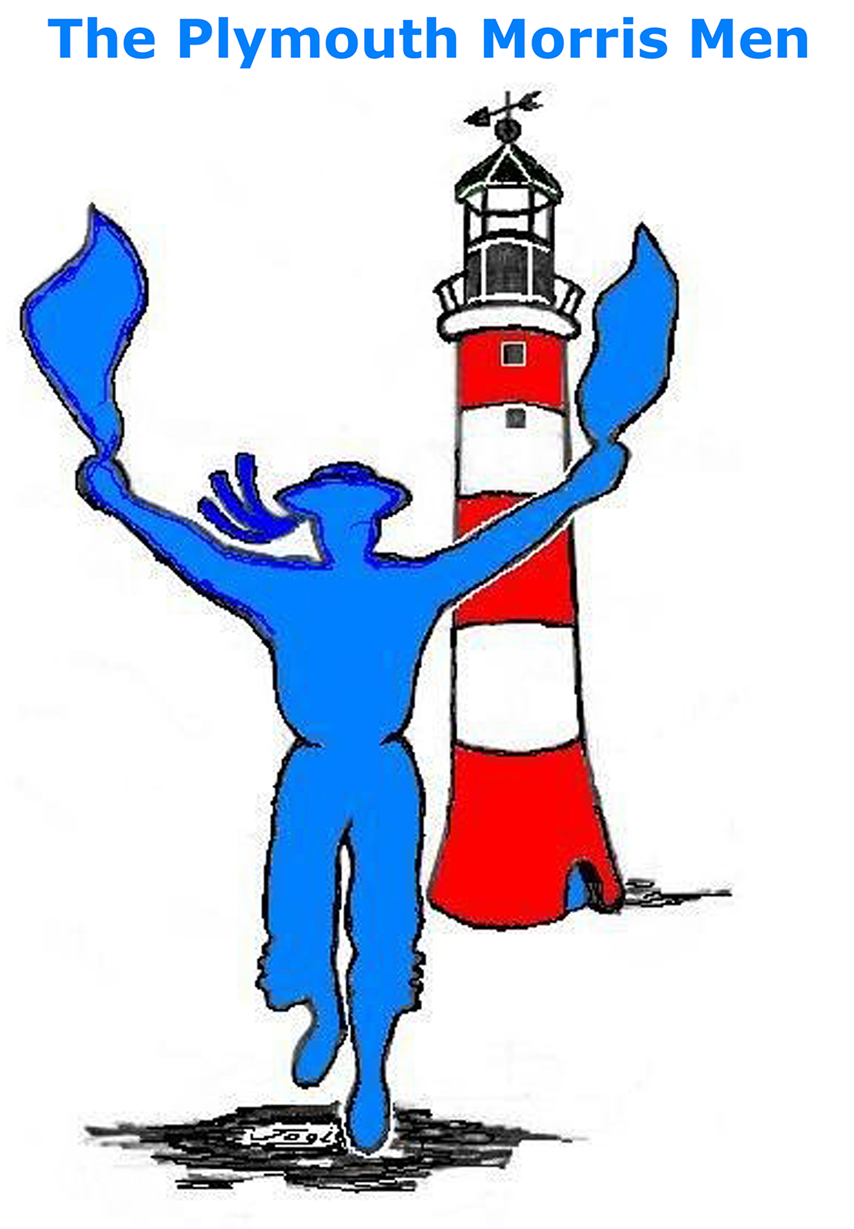
Wed 23 19:30 Challaborough Bay Holiday Park
Updated: Tuesday 16 September 2014

E-mail: plymouth.morris@blueyonder.co.uk
PMM website: www.plymouthmorrismen.org.uk/
Photographs: www.flickr.com/photos/4-sharing/sets
Video: http://www.youtube.com/user/Plymouthmorrismen2
GPS and maps: http://www.plymouthmorrismen.org.uk/2014-programme
20:15 Journey’s End, Ringmore

Wed 30 19:30 Hoe, and Pub on the Hoe
August 2014

Sun 03 11:00 Sidmouth Folk Week (02-09/8)
14:00 both spots near the Sailing Club

Wed 13 19:30 Fireworks Championships, Barbican

Wed 20 19:30 Peter Tavy Inn, Peter Tavy

Sat 23 12:00 Wilcove Inn, Wilcove

Thu 28 20:00 Barbican: Rock Fish & Elphinstone
w/Plymouth Maids

Sat 30 14:00 Plymstock Festival

September 2014
Our collections during 2008
will be dedicated to
St Austell Brewery Charitable Trust
To book us for your function, please contact the Bagman:
Peter  01752.330249

Wed 03 19:30 Morley Arms, Laira Bridge

05-07 DARTMOUTH: Morris Ring Meeting

Wed 10 19:30 Ferry House Inn, Saltash Passage

Sat 13 10:00 OCEAN FESTIVAL: Day of Dance

Sun 21 11:00 TOTNES FESTIVAL: Day of Dance

Wed 24 19:30 Dolphin, Barbican

October 2014

Wed 01 19:30 Annual General Meeting

17-19 St MABYN:
Fools and Animals Unconvention

Tue 21 19:30 Trafalgar 209 - Morley Arms

December 2014

Wed 17 19:30 Horse & Groom, Bittaford

Fri 26 12:00 Morley Arms, Laira Bridge
with Plymouth Maids

